Science Learning with an AI Assistant

Imagine it’s 2030. Artificial intelligence (AI) is widely used in the classroom to assist teaching. If you are curious about how it may work, this activity is for you!

There will be many ways in which you can learn science with AI in the future. This activity introduces one of those ways. You will partner with a “teammate” — like in many science projects — to co-design a photovoltaic solar panel array that generates the most electricity on a given day in Miami, Florida. Unlike those projects, however, your “teammate” is not a human being but an AI assistant called Alice. You should try to come up with an optimal design based on the science concepts such as the Sun’s path, seasonal change, daytime length, and the projection effect provided to you in Knowledge Cards for your reference during this activity. Alice will assist you while you are solving the problem.

The activity has two parts. In Part I, you will work with Alice to find an optimal solution for a winter day. In Part II, you will work with her to find an optimal solution for a summer day.

Part I: Find the Optimal Tilt Angle for a Winter Day

The goal is to find a tilt angle for a row of solar panels that results in maximal output (kWh) on December 22 (the tilt angle is explained in the image below). You will first make a guess based on your understanding of the science concepts. Then you will ask Alice how it may be improved. If her solution is indeed better than yours, analyze it carefully to figure out why before you make your next move. Repeat this process until you reach the goal. You will know that you have come close to the goal when Alice can no longer return a better solution.
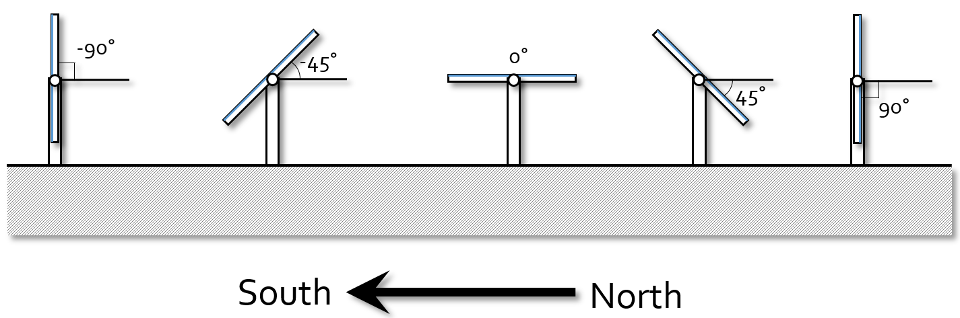

The tilt angle of a solar panel is the angle between its surface and the surface of the ground. In Energy3D, the tilt angle must be between -90° (facing south) and 90° (facing north).

Read the following instruction carefully before you start.

A. Explore the problem

You will first use some tools in Energy3D to investigate the problem and connect it to the science concepts introduced in the Knowledge Cards.

- Open the file. Double-click on “solar-panel-tilt-angle-experimental.ng3” in the desktop (or anywhere the file has been downloaded to). Once the file opens in Energy3D, you should see a single row of solar panels. The date should be already set to December 22 and the location to Miami. The panels are originally placed in a vertical direction, facing south.
- Experiment with the tools. Use the following Energy3D tools to explore the orientation of the solar panel array in relation to the Sun and its possible effect on the output.

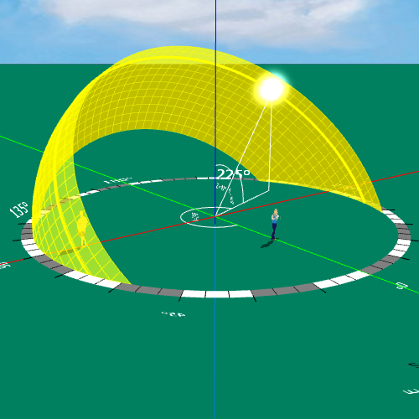 |  | The heliodon is a tool for showing the Sun path throughout the year. It can be used to study the daily and seasonal path of the Sun across the sky as the Earth rotates and orbits the Sun. The Sun path affects the length of daytime and the amount of daylight received at a given location during a given day. Click on the toolbar to turn the heliodon on and off.
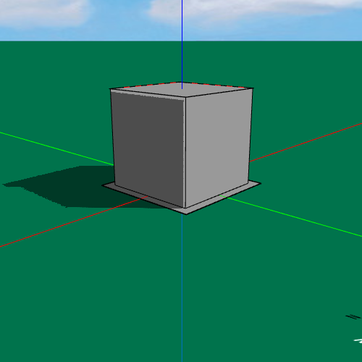 | The shadow button on the toolbar can be used to turn shadow on and off. Shadow analysis allows you to examine how one object may affect the amount of sunlight another receives at any given moment, depending on their relative positions.
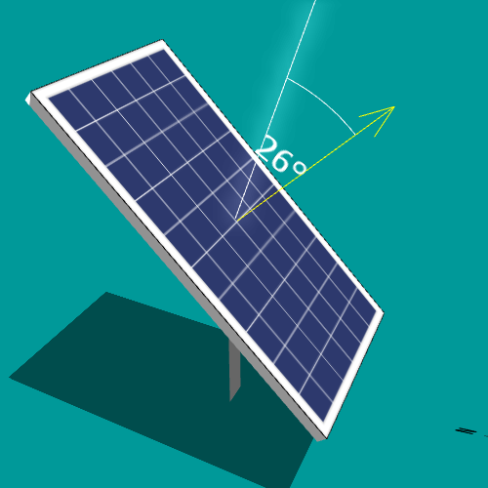 | You can also turn on the sunbeam, which is a line indicating the direction of the sunlight that strikes the surface of a solar panel. The angle between the direction of the sunbeam and the direction which the solar panel faces is displayed as well. To show or hide the sunbeam, right-click on a solar panel and select or deselect Draw Sun Beam from the popup menu.

B. Choose a tilt angle and calculate the output

After you have explored the problem, take an educated guess about the best tilt angle and then follow these steps to calculate and document the results.

- Set the tilt angle. Right-click on the solar panel array and select Fixed Tilt Angle… from the popup menu. A window with a text field will open. The initial tilt angle is -90° (facing south). Enter a value that you think would be a good tilt angle and press OK.
- Analyze the daily output. Click the Calculate button in the Sheet 1 of the Instruction & Documentation area. A window that has an empty graph should open. Click the Run button in the window to calculate the daily output. When the calculation completes, a graph that shows the hourly outputs should appear and the total output should also be reported. Examine the graph to see if the results make sense.
- Document the results. Write down the tilt angle you selected and the calculated daily output in Table 1 on your answer sheet (provided to you separately) and also answer the questions in Table 1. Each question has a designated point value on a 100-point scale. An Instructor may grade your answers.

C. Work with Alice to improve your solution

How do you know if your choice of the tilt angle is a good one? Alice can help! To assist you, she will evaluate your solution and come up with an improvement. Although Alice is not able to talk to you, she will provide a table that summarizes her changes and some graphs that compare your results with hers. It is your job to analyze what Alice presents to understand why she makes her suggestion.

- Let Alice help you. Click the Ask Alice button in the Sheet 1 of the Instruction & Documentation area. If the area is not showing on the right-hand part of Energy3D, clicking on the green ground in the view window will bring it back. Once you click the button, Alice will do some calculation to evaluate your work and search for improvement. Give her a moment to “think about it.” While waiting for Alice to finish, you may watch her “thinking” process shown on the screen. (If necessary, you can stop Alice by clicking the Stop Alice button. Most of the time you don’t need to stop her, but if you do, you will need to start over from your solution as she does not remember it.)
- Document Alice’s advice. After Alice finishes, she will report her solution side by side with yours in a window. Write down her tilt angle and daily output (i.e., objective) in Table 2 on the answer sheet and answer the questions.

D. Iteratively improve the solution with Alice

Iteration is an essential process by which engineers repeat a sequence of steps to get closer to a desired result. Now that you have feedback from Alice on your solution, repeat the steps described in B and C above until neither you nor Alice can improve further. You will know you have reached the maximal output when Alice generates approximately the same solution. Keep track of your progress in the Table 3 on the answer sheet and write down the optimal tilt angle that you and Alice have found.

Part II: Find the Optimal Tilt Angle for a Summer Day

In the summer, the Sun moves in a different path than in the winter. Will the tilt angle you and Alice found from Part I still be the optimal one? Set the date to June 22 (or click 06/22 in the Sheet 1 of the Instruction & Documentation area), repeat what you and Alice did in Part I, and find out the answer!

