Solar Urban Design
Design Specs

The Boston Redevelopment Authority has opened bids for redesigning a city block (100 m x 100 m) in the downtown area. As the chief engineer of a startup company focusing on sustainable city planning, winning the bid is important to you. Your job is as follows:

- Design new construction buildings in the empty, leveled city block:
- At least two high-rise buildings: These are for residence and offices. They should be at least 60 meters tall but should not be taller than the highest existing building in the neighborhood.
- At least two low-rise buildings: These are for shops or services such as restaurants, book stores, or pharmacies. They should not be taller than 20 meters.
- A balance of built and open space: Approximately ⅓ of the block must be constructed with high-rises and ⅓ with low-rises. The remaining ⅓ must be open space.
- At most eight new buildings (including high- and low-rises) in total are allowed in the block.
- Don’t add windows: We assume that windows will be added proportionally to the total surface areas of each building later.
- Don’t add solar panels, doors, floors, and any interior structures. You may add trees and people in the open space or on the street if that makes your design look nicer.
- Parking areas, subway, or bus stations need not be considered.

- Consider energy from the sun in different seasons (you will use the Solar Radiation Simulator in Energy3D to investigate these issues and make design decisions) :
- Optimize solar gains of the high-rise buildings in the winter and summer: The locations and shapes of the high-rise buildings should be chosen such that they receive as much total solar energy on December 31st as possible to lower the heating costs in the winter AND as less total solar energy on June 30th as possible to lower the cooling costs in the summer. (Note: Do NOT use the Annual Energy Analysis Tool in Energy3D to do this analysis.)
- No need to consider the solar gains of the low-rise buildings: They do not need a lot of sunlight because they accommodate business facilities that usually do not have many windows.

- You must come up with three DIFFERENT designs and choose the best among them to represent your firm. There are many different ways in which you can design your city block. For example, you can explore the solar performances of different shapes, such as L-shape, T-shape, U-shape, or courtyard, in each design. Once you decide on the shapes, you can also test different layouts to optimize their solar gains both in the winter and summer. If you have a number of design strategies that may not be compatible to one another, you should try to use them separately in different designs and then make a trade-off decision based on comparing their overall quality.

- You should spend 1-2 class periods to plan, construct, experiment, analyze, and document each of the three designs. Until this project is over, you can always revisit and improve a previous design.

Instructions
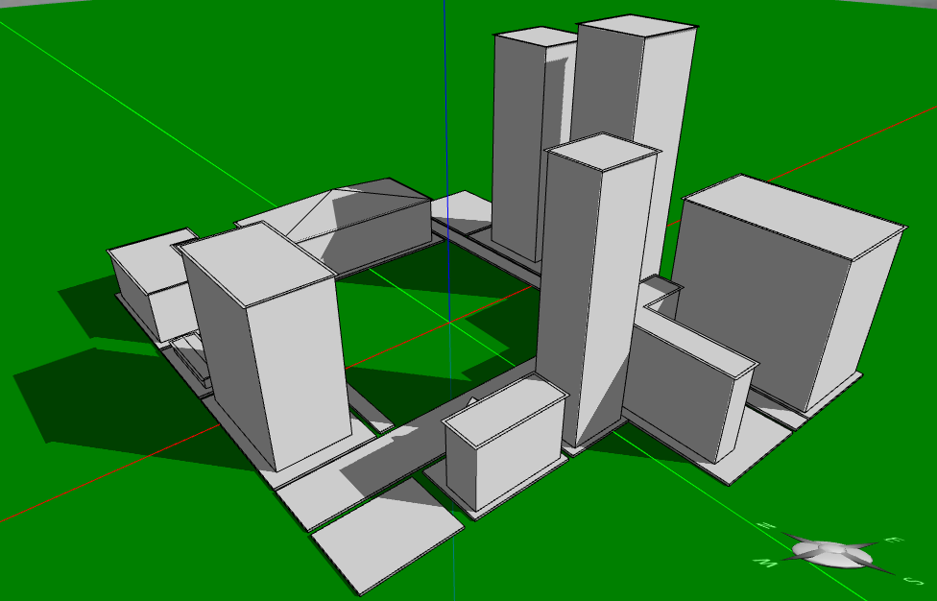

The Boston Redevelopment Authority has provided a computer model of the city block with existing surrounding buildings. Three identical copies of this model can be found on your USB drive and can be opened using the Energy3D software. The image to the right shows how this computer model looks like within Energy3D (the existing buildings in it are grayed out because they cannot be modified).

To get started,
- Write your name on the tag attached to your USB drive.
- Connect the USB drive to the computer and then open the USB folder on the computer.
- Double-click energy3d.jar on the USB drive to run Energy3D.
- Use the “File > Open” menu to open cityblock-design1.ng3 on the USB drive. Start working on your first design using this file as the starting point. While designing, use the “Edit > Show Note” menu to open a text area below the 3D view window. The text area provides some instruction, questions, and a check list to guide you through the design process. You must answer those questions based on your design. Save everything you have done in this file—do not save your work into a different file unless you want to keep a backup copy.
- Open cityblock-design2.ng3 to work on your second design.
- Open cityblock-design3.ng3 to work on your third design. Note: The three ng3 files contain exactly the same model initially—the surrounding buildings are identical in all three files.
- Each of your three designs should feature different buildings and layouts. For the design you pick as the best one for the bid, explain why you make that choice in the text area. Refer to the buildings using the numbers on top of them as if they were street addresses.
- At the end of each session, remember to save your design. You MUST save all your work in the USB drive (as you may use a different computer next time). Do NOT just pull the USB drive—use the EJECT function of the computer to safely remove it.

Important Notes

- Each building must have its own platform. Don’t put multiple buildings on a platform.
- A building can be resized or rotated as a whole at any time. You can concentrate on designing its shape initially and resize or rotate it as you wish later.
- Always document your work. Your notes will be saved when you save your design.

