The Solarize Your House project is an engineering design project that solves a real-world problem. Completing a thorough home site survey is vital to the success of the project.
Site Survey Instruction Sheet
Home Site Survey Checklist:
□ Electricity bill □ Photogrammetry measurements □ Tree locations around house

Electricity Bills
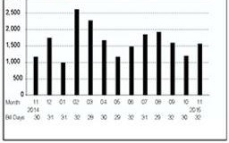
Your utility company should provide you with your annual electricity use by month. This data is usually available in a graph on the front of your bill with exact usage each month listed on the back of your bill. In some cases, it may be necessary to call your electricity company to collect this information. To correct for yearly fluctuations in temperature, it would be ideal to average your monthly electricity usage over a three year period. However, if this is not possible usage from one year will do. Please use table below to record this information:

Month | Monthly  kWh Usage  Year 1 | Monthly  kWh Usage  Year 2 | Monthly  kWh Usage  Year 3 | Average Usage for 3 Years

Jan

Feb

Mar

Apr

May

Jun

July

Aug

Sep

Oct

Nov

Dec

Photogrammetry Instruction (Optional)

If your house has a 3D model in Google Earth, then you do not need to bother with this section. Please refer to “Google Earth Instruction Sheet” for information on how to obtain the height of your roof.

Photogrammetry is the use of photography to measure distances between objects. You will use photography to measure the rise of your roof and the height of your walls.

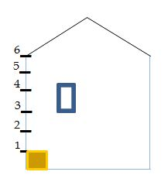
1. Scaling Tool - Locate a large square or rectangular object (for example a large print book) that can stand on its own and place it next to the house in a place that you take a picture of the object and the whole side of the house. (Alternatively, measure out 3 feet of masking tape taped to the side of your house.)
0.5’
1’
2. Record the length and width of the your scaling tool (1’x0.5’)
2. Paste the photo of your home with the scaling tool in a Word document.
3. Wall Height - Insert a line that is the same size of the length of your scaling tool. Copy and paste the same line stacking one on top of the other as many times as possible. Stop at the top of the wall where the roof begins. Multiply the total measurement of scaling tool by total number of lines stacked.
Wall height = (scaling tool length) x (total number of lines)
7_
8_
Rise
Convert to meters: ft * 0.3048

4. Rise – Continue stacking the scaled line from the top of the wall until it reaches the top peak of the roof. Multiply the total of the scaling tool by the total number of lines stacked.
Rise of roof = (scaling tool length) x (total # of lines)
Convert to meters: ft * 0.3048
5. Go to “SmartCARD3: How do I get exact dimensions?” or watch the SmartVIEW2 video tutorial and learn how to adjust your Energy3D model to match the wall height and rise measurements that you have just measured.

