4.3 Design requirements of ground-mounted solar panel arrays

Understand the design goal
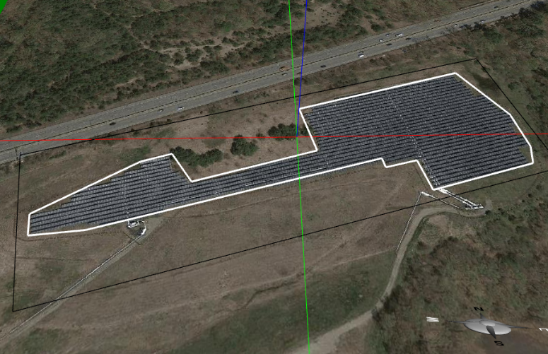
Figure 4.3.1: The specific area is enclosed within the white polygon displayed on a foundation in Energy3D.

Given a piece of flat land in a certain shape at a certain location (e.g., Figure 4.3.1) and a budget for purchasing and installing solar panels, design arrays of ground-mounted solar panels (often known as solar farms) that generate maximum electricity over the course of a year. The arrays must have minimal negative impact on the landscape (e.g., they must be neatly aligned; they are hidden behind trees when viewed from the road).

Import a map image of a site
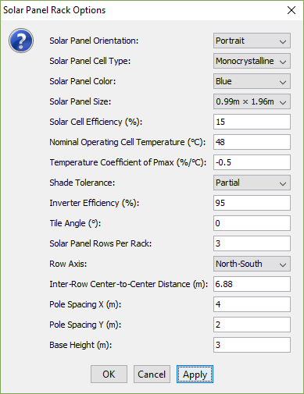
Figure 4.3.2: The Layout Wizard for Solar Panel Rack Arrays in Energy3D.

If you haven’t been provided a template file, the first thing you will need to do is to import a site image from Google Maps. You can do this by going to “View → Ground Image → Use Image from Earth View…” in Energy3D.

Lay out solar arrays

In Energy3D, your solar array must be placed on a foundation, which is a rectangular area. In reality, your site may not be rectangular. You can right-click on the foundation and choose “Border Line” from the popup menu. A white polygon will appear on top of the foundation. Drag the vertices of this polygon to set the area of the land on which your solar array will be deployed. If you have multiple arrays, you must use a foundation for each one of them. By default, a foundation is placed along the North-South axis. If you want your array to face a different direction, you will need to rotate a foundation.

After you have set the area to the right shape and size, you can add solar racks to it one by one and make sure that each rack is within the white polygon. But this may be tedious and slow. Energy3D provides a layout wizard to fill up the area quickly with the parameters that you can specify (Figure 4.3.2). To use this wizard, right-click on the foundation and select “Layout → Solar Panel Rack Arrays…” from the popup menu.

Choose solar panels

In the layout wizard, you must specify the properties of the solar panels to be added. You must use one of the following solar panel brand models:

Brand | SunPower | LG | Hyundai
Model | SPR-X21-345-C-AC | LG300N1C-B3 | HiS-M280MI
Cost per Panel ($) | $1380.00 | $1050.00 | $840.00
Cell Type | Monocrystalline | Monocrystalline | Polycrystalline
Temperature Coefficient of Pmax | -0.29%/°C | -0.41%/°C | -0.45%/°C
Nominal Operating Cell Temperature | 41.5°C | 45°C | 46°C
Cell Efficiency | 21.17% | 18.29% | 14.43%
Dimension | 1.04m × 1.55m | 0.99m × 1.65m | 0.99m × 1.96m
Shade Tolerance | High | Partial | Partial
Data source: http://get.solardesigntool.com/
There are also array properties that you can set with the layout wizard. These include: 1) Orientation: Portrait or Landscape that specifies how each solar panel is placed on a rack; 2) Solar panel sub-rows per rack: This is how many sub-rows of solar panels you would like to put on each rack; 3) Row axis: This sets the direction in which the array will face; 4) Tilt angle: This is how each rack will be oriented towards the sun; 5) Inter-row center-to-center distance: This sets how far each row will be from its adjacent ones from center to center; 6) Pole spacing: This sets how many poles you would need for each rack; and 7) Base height: This sets the height of the center of each rack (a low value of this may lead to rejection if it causes the lowest solar panels to penetrate into the ground).

Analyze your design

After you have created a solar panel array, you can analyze its daily output or annual output using the analysis tools in Energy3D. To use the analysis tools, right-click on a foundation and select “Analysis → Daily Solar Panel Yield Analysis…” or “Analysis → Annual Solar Panel Yield Analysis…” from the popup menu.

Iteratively improve your design

You won’t be able to get everything right at first try. Try changing the parameters a few times and compare the annual yields to see if the results are different. Make a decision based on evidence, not guess.

Documentation and report

Follow the design journal while working on the project. At the end of the project, complete a final report that summarizes your design and justify your ideas with simulation results and analyses based on Energy3D. Submit your design journal and final report to your teacher.

