3.3 Ground-mounted solar panel arrays

The challenge
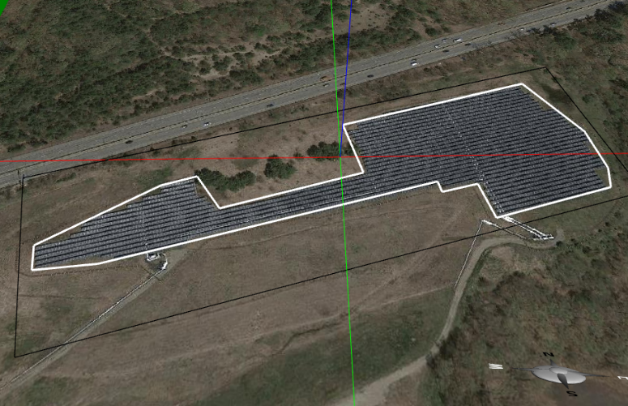
Figure 3.3.1: The specific area is enclosed within the white lines displayed on a foundation in Energy3D.

Given a piece of flat land in a certain shape at a certain location (e.g., Figure 3.3.1) and a budget for purchasing and installing solar panels, design arrays of ground-mounted solar panels (often known as solar farms) that generate maximum electricity over the course of a year. The arrays must have minimal negative impact on the landscape (e.g., they must be neatly aligned).

Science concepts and engineering principles

Tilting solar panels
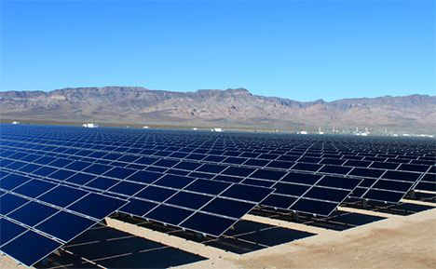
Figure 3.3.2: Solar panel rows in the landscape orientation.
In order to receive more solar radiation, solar panels should be tilted. An appropriate tilt angle not only orients a solar panel towards the sun, but also ensures rain to wash it more thoroughly and snow to slide off more quickly. The exact optimal tilt angle depends on the location, but other factors such as wind loads may affect the decision—solar panel arrays must withstand strong wind. As wind normally blows in the horizontal direction, a larger tilt angle results in greater pressure on a solar panel.

Keeping an inter-row distance

Solar panels can be piled up on a rack to form a row. Each row may consist of multiple sub-rows. Solar panels in each sub-row can be placed either in the landscape or portrait orientation (Figure 3.3.2). Rows of such arranged solar panels form an array. In high-latitude areas such as northern United States, if adjacent rows are too close, the effect of inter-row shadowing may reduce the outputs of the array when the sun is low in the sky such as in early morning, late afternoon, or the winter. The inter-row distance depends on the number of sub-rows in each row. The more sub-rows, the greater the inter-row distance should be.

Tracking the sun

Solar trackers that automatically orient solar panels towards the sun throughout the day can increase power generation (Figure 3.3.3). There are a number of trackers to use, such as the horizontal single-axis tracker (HSAT), the vertical single-axis tracker (VSAT), and the alt-azimuth dual-axis tracker (AADAT), but they will affect the design of the solar array. VSAT and AADAT are not applicable to long rows.
Figure 3.3.3: Solar trackers allow solar panels to follow the sun like sunflowers.

Designing for cost effectiveness

Engineers strive for cost-effective solutions. A solution that can produce more electricity is not necessarily a better one if it uses more solar panels. For example, maximal output of a piece of flat land can be ensured by covering the entire area up with solar panels at zero tilt angle, leaving no gap and margin. This solution captures nearly all the light energy that shines on the area, but it may not be the most cost-effective one in high-latitude areas because individual solar panels may not generate more electricity than those in tilted arrays.
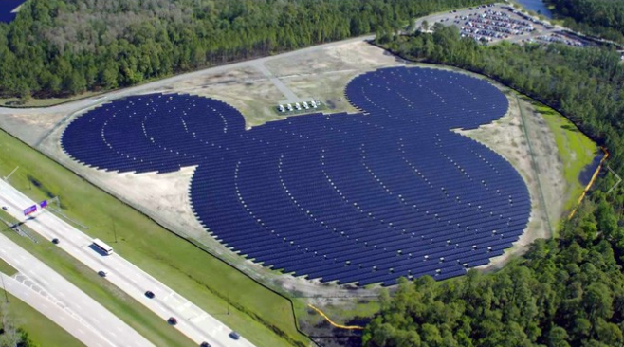
Figure 3.3.4: Disney World’s Mickey Mouse-shaped solar farm integrates solar energy and advertisement.

Design idea exploration

Innovative solar designs often come from creative ways to integrate solar panels with other facilities. Use your imagination and ingenuity to explore new ways to solarize your world. For instance, Disney World’s Mickey Mouse-shaped solar farm combines solar energy with advertisement (Figure 3.3.4). If land is scarce and expensive, solar panels can also be installed atop bodies of water (Figure 3.3.5), such as fish farms and water treatment plants. When applying this idea to reservoirs, solar panel arrays can reduce the surface temperature of water and slow down evaporation, thus conserving water and generating electricity simultaneously. Floatovoltaics extends this idea further by putting solar panel arrays on floating platforms that can easily move.
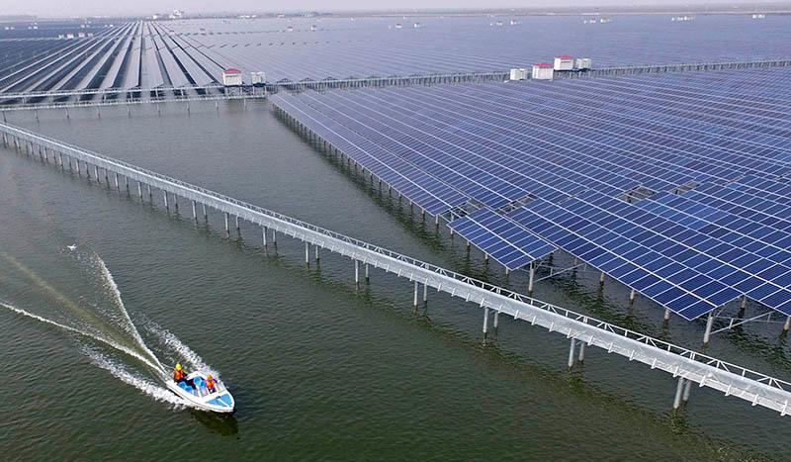
Figure 3.3.5: Integrating a solar farm with a fish farm to produce energy and food.

Design requirements
Your design must address the following criteria and constraints.

The criteria
Return on investment: The payback period must be as short as possible. To do so, the solar panel arrays you design must be cost-effective and must generate as much electricity as possible.

The constraints
Your arrays cannot exceed the boundary of the site. You must consider room for maintenance such as cleaning and repairing.

The design variables
To create an optimal design, you should:
- Choose from three different solar panel products (see the Solar Panel Product Information sheet for product specifications);
- Use different sizes, tilt angles, panel orientation, and total number of solar racks;
- Experiment with different arrangements for placing solar panel racks to optimize the performance of your design.

Design steps

Choose a site

You can choose a site near you that already has one or more solar panel arrays. Some of these sites are available for download from the Solarize Your World Site Inventory (http://energy.concord.org/energy3d/sites.html). To get started, you can build a model of the existing arrays and analyze their outputs in Energy3D. You can then try to improve the result by tweaking the model or completely redesigning it. You can also select a site that has not been solarized or is not in the Site Inventory, such as the landfill of your town, if the land is largely flat. When picking a site, favor those that have been ecologically disturbed (i.e., constructing a solar farm on top of it would have a minimal impact on the local environment). If you don’t know about such a site, talk to the sustainability manager of your school or town if possible.
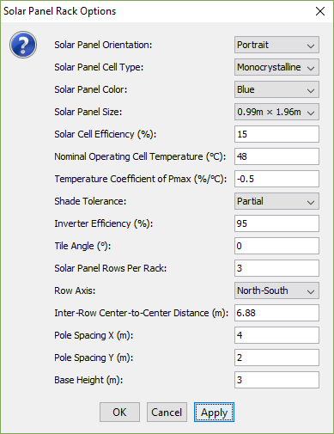
Figure 3.3.6: The Layout Wizard for Solar Panel Rack Arrays in Energy3D.

Import a map image of a site

If you haven’t been provided a template file, the first thing you will need to do is to import a site image from Google Maps. You can do this by going to “View → Ground Image → Use Image from Earth View…” in Energy3D.

Lay out solar arrays

In Energy3D, your solar array must be placed on a foundation, which is a rectangular area. In reality, your site may not be rectangular. You can right-click on the foundation and choose “Border Line” from the popup menu. A white polygon will appear on top of the foundation. Drag the vertices of this polygon to set the area of the land on which your solar array will be deployed. If you have multiple arrays, you must use a foundation for each one of them. By default, a foundation is placed along the North-South axis. If you want your array to face a different direction, you will need to rotate a foundation.

After you have set the area to the right shape and size, you can add solar racks to it one by one and make sure that each rack is within the white polygon. But this may be tedious and slow. Energy3D provides a layout wizard to fill up the area quickly with the parameters that you can specify (Figure 3.3.6). To use this wizard, right-click on the foundation and select “Layout → Solar Panel Rack Arrays…” from the popup menu.

Choose solar panels

In the layout wizard, you must specify the properties of the solar panels to be added. You must use one of the following solar panel brand models:

Brand/Model | SunPower  SPR-X21-345-C-AC | LG  LG300N1C-B3 | Hyundai  HiS-M280MI
Cost per Panel ($)
Small project (1-99 panels) | $1380 | $1050 | $840
Medium project (100-999 panels) | $690 | $525 | $420
Large project (>1000 panels) | $345 | $263 | $210
Cell Type | Monocrystalline | Monocrystalline | Polycrystalline
Color | Blue | Black | Blue
Cell Efficiency | 21.5% | 18.29% | 14.43%
Size | 1.04m × 1.55m | 0.99m × 1.65m | 0.99m × 1.96m
Nominal Operating Cell Temperature | 45°C | 45°C | 46°C
Temperature Coefficient of Pmax | -0.29%/°C | -0.41%/°C | -0.45%/°C
Shade Tolerance | High | Partial | Partial
Annual Degradation Rate | 0.25% | 0.70% | 1.00%
90% Power Output Warranty Period | 25yrs | 10yrs | 10yrs
Data source: http://get.solardesigntool.com/

There are also array properties that you can set with the layout wizard. These include: 1) Orientation: Portrait or Landscape that specifies how each solar panel is placed on a rack; 2) Solar panel sub-rows per rack: This is how many sub-rows of solar panels you would like to put on each rack; 3) Row axis: This sets the direction in which the array will face; 4) Tilt angle: This is how each rack will be oriented towards the sun; 5) Inter-row center-to-center distance: This sets how far each row will be from its adjacent ones from center to center; 6) Pole spacing: This sets how many poles you would need for each rack; and 7) Base height: This sets the height of the center of each rack (a low value of this may lead to rejection if it causes the lowest solar panels to penetrate into the ground).

Analyze your design

After you have created a solar panel array, you can analyze its daily output or annual output using the analysis tools in Energy3D. To use the analysis tools, right-click on a foundation and select “Analysis → Daily Solar Panel Yield Analysis…” or “Analysis → Annual Solar Panel Yield Analysis…” from the popup menu.

Iteratively improve your design

You won’t be able to get everything right at first try. Try changing the parameters a few times and compare the annual yields to see if the results are different. Make a decision based on evidence, not guess.

Documentation and report

Follow the design journal while working on the project. At the end of the project, complete a final report that summarizes your design and justify your ideas with simulation results and analyses based on Energy3D. Submit your design journal and final report to your teacher.

