Solar Assessment Report
Prepared for: 15 Muddy Pond Road Sterling, MA
Prepared by: Scott Ogle Date: 06/06/2016

Part A: Background Information

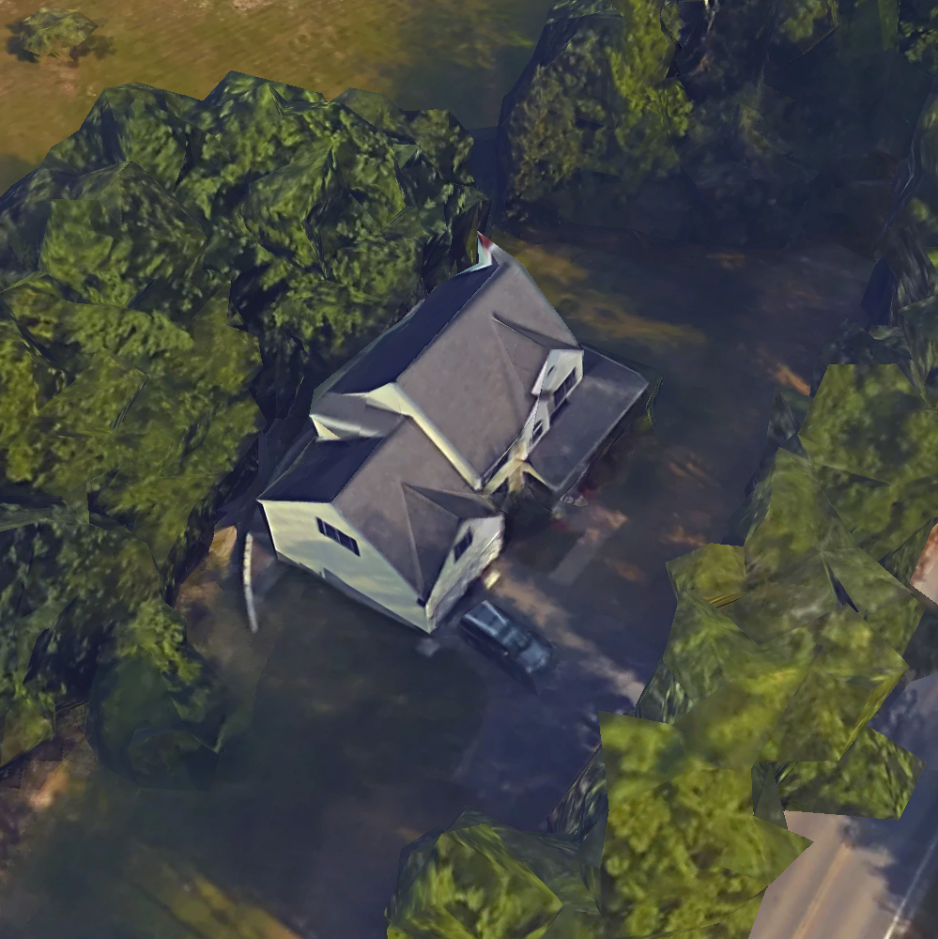 | 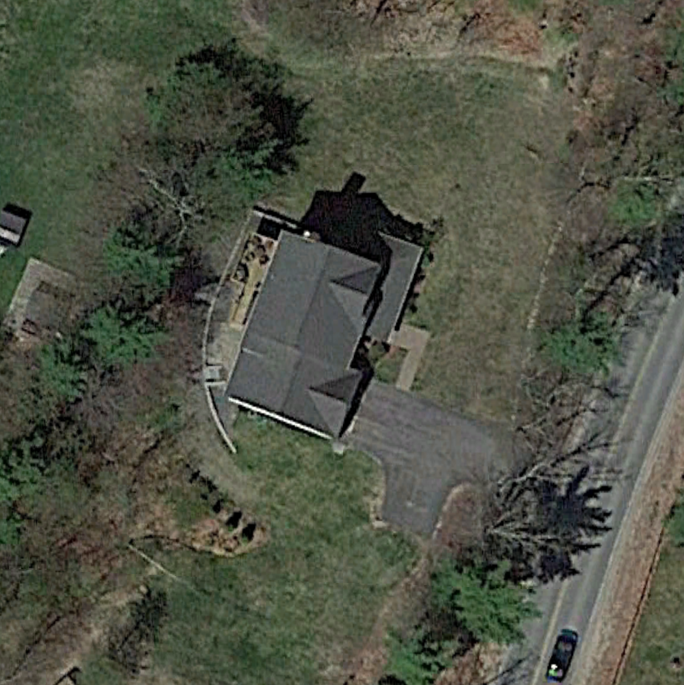

Part B: Solar Panel Cost Analysis

Fill out the table below according to the costs incurred by your system:
Design Challenge | Design #1  Budget <$20,000 | Design#2  Budget <$40,000 | Design#3  Budget <$60,000
Solar panels (cost per panel times the number of panels) | $705.0 per panel $×$28 panels | $705.0 per panel $×$56 panels | $1897.5 per panel $×$31 panels
Tree removal $1000 | - | - | -
Total | $19740.0 | $39480.0 | $58822.5

For this design challenge you need to keep within your budget limits without taking into account Federal and State incentives that may available in your area. Government incentives may only be offered for a limited time and are variable depending on current policies. However, the incentives are in place to make going solar more affordable, so you will adjust your cost below to account for these government programs.

Current Federal and State Incentives
- 30% Federal Tax Credit | -5922.0 | -11844.0 | -17646.8
- $1000 State Incentive | -1000.0 | -1000.0 | -1000.0
Total After Incentives: | 12818.0 | 26636.0 | 40175.8

Part C: Solar Panel Yield Analysis

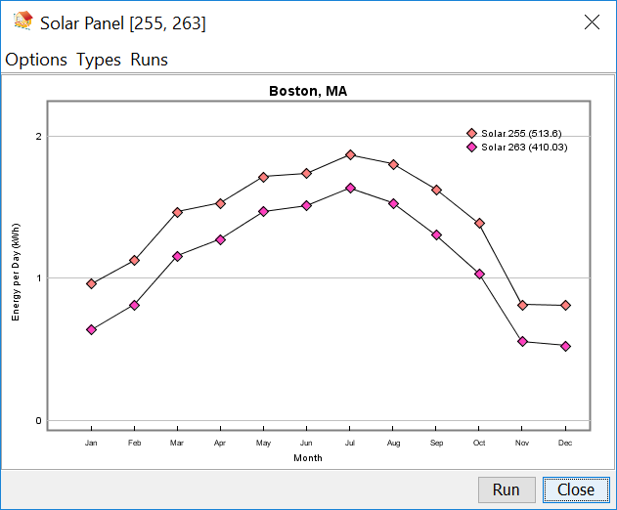
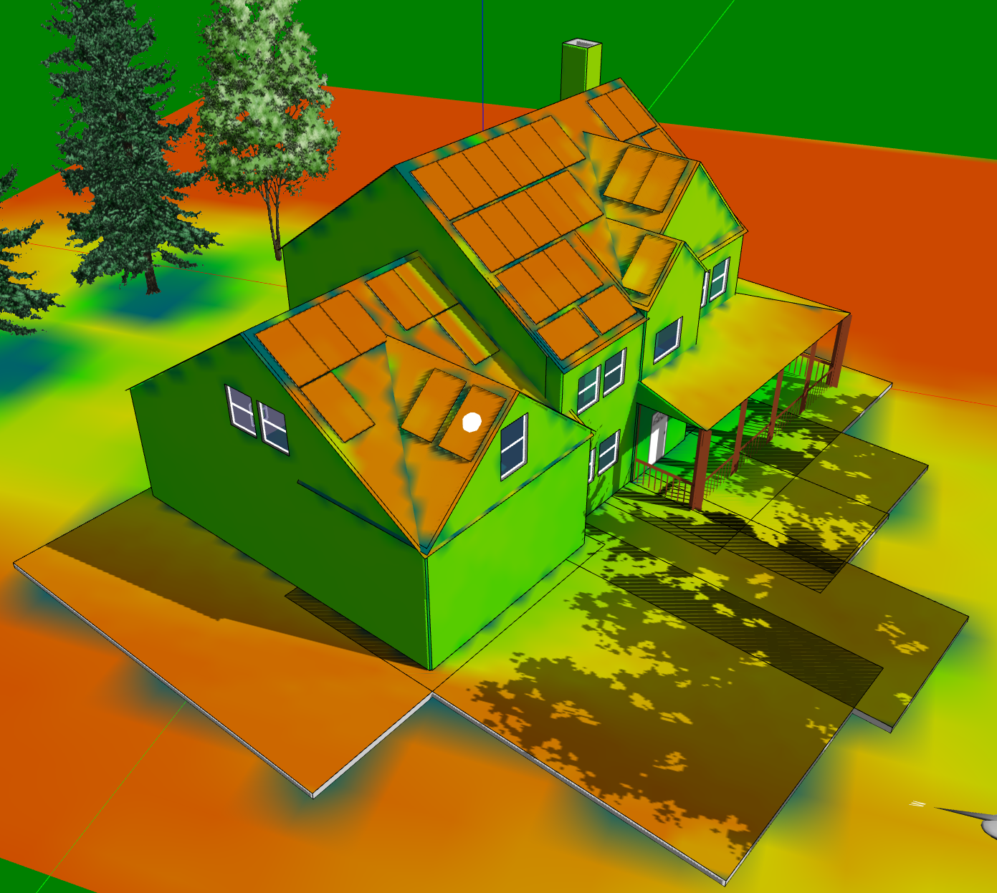 | 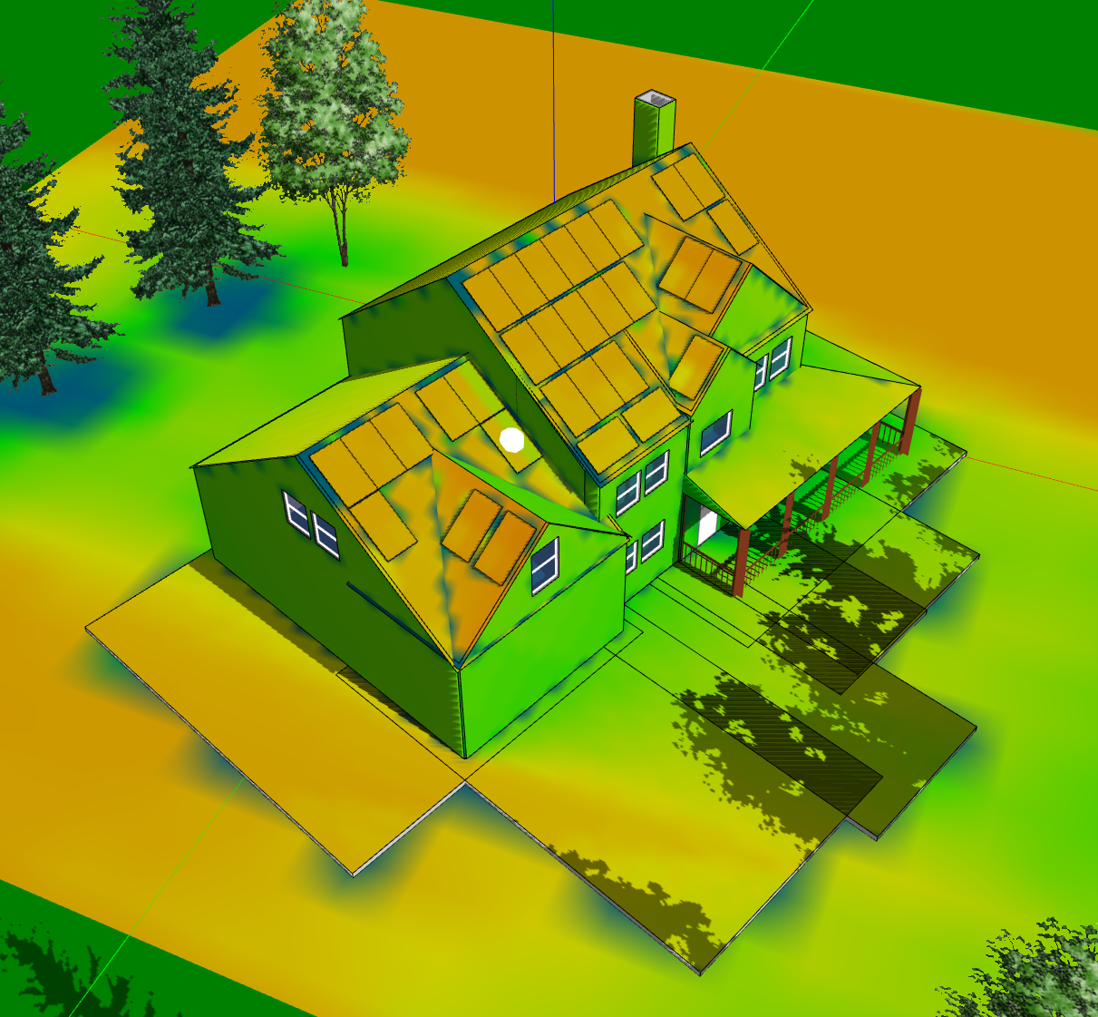
1a) What factors affect the effectiveness of this panel?  It is south-west facing and is not heavily obstructed much by the surrounding trees. | 1b) What factors affect the effectiveness of this panel?  It is partially blocked by the overhang of the adjacent roof (since it is higher than the garage roof).
2a) Are there any times or conditions where the above panel performs worse than its typical performance? Explain why.  It is outperformed by several higher, south-east facing panels in June and July since it is shadowed by the roof of the dormer in the morning in summer. | 2b) Are there any times or conditions where the above panel performs better than its typical performance? Explain why.  During the winter months the adjacent roof does not cast a shadow on this panel, so it performs the same as the surrounding panels.

Part D: Three Solar Panel Layout Designs ($20,000/$40,000/$60,000)

Design #1, Budget - $20,000
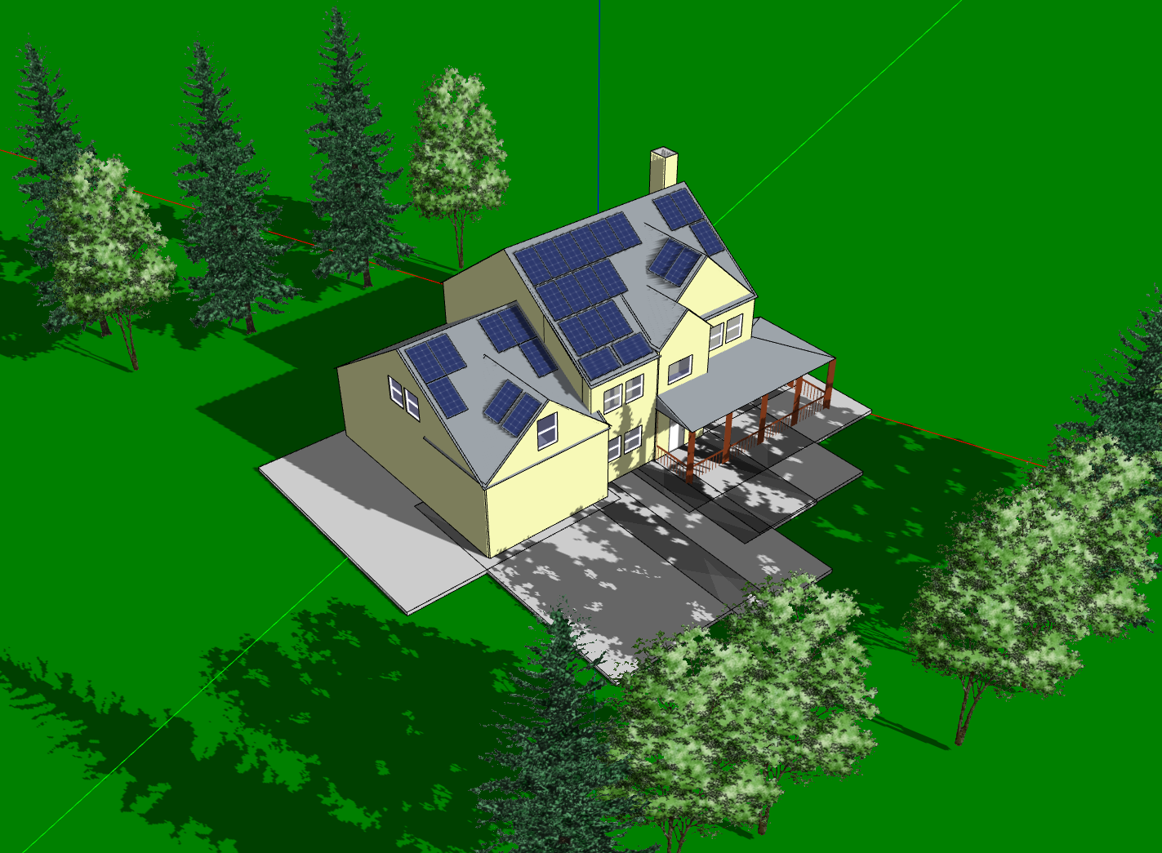 | 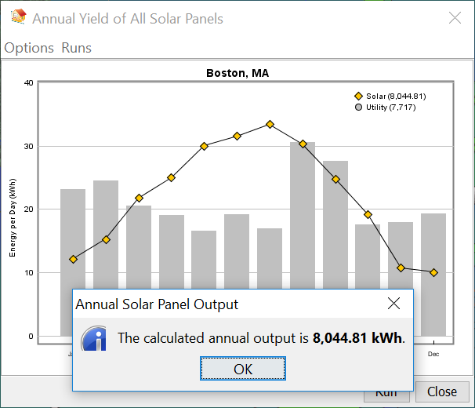
1) Was your design #1 able to produce the amount of energy that meets the needs for electricity of the house?

My design #1 shows that the annual output (8044 kWh) exceeds the needs for electricity of the house (which is 7717 kWh based on my utility bill). However, according to the comparison between household usage and system generation on a monthly basis below, solar panels generate more electricity than needed in summer (June and July, for instance) and less than needed in winter (December, January, etc.). And in Spring and Fall, solar energy produced is roughly the same as energy consumed, such as in March, September, and October.

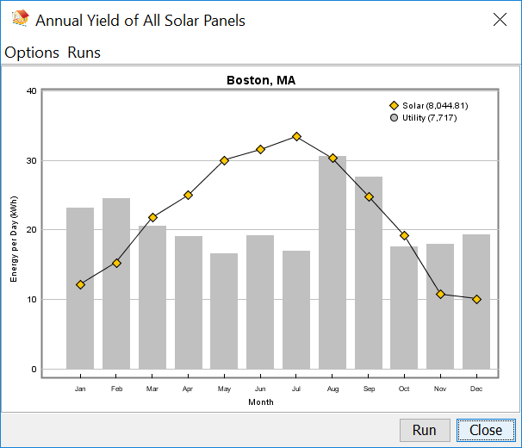

2) What is the brand, wattage, solar cell efficiency, and cost of the panels you selected for Design #1? Why did you select this panel type for your design over other types?

The brand I choose is Sharp NU-U235F3, which has 235 max wattage and 14% efficiency. The total cost of the panels are $19740. I choose this panel type over others since it is the most cost effective, for example, although it is 2% less in terms of efficiency as compared to Hyundai 280, it cost $275 less per panel. Panels with better efficiency are even more financially prohibitive. For instance, although SunPower X21-345 has 22% efficiency, it costs $1897.5 per panel. Given my budget limit in this design ($20,000), I can only install 10 panels, and the estimated annual energy generation (4487.13kWh) can hardly meet the need.

3) What features of the house and the surrounds have a positive influence on your solar panel layout? Explain how these features influence the panels.

Features of the house and the surrounds that positively influence my solar panel layout are:
- This house is relatively large, and the area of its main roof is 131 m². Thus, it provides enough space of preferred orientation to place panels. I actually positioned almost all my panels on the part of the roof that faces either east or south.
- The trees that locate at the east and west side of this house are not too close, thus they do not cast much shadow on the panels.
- There are no trees or buildings that are tall enough to cast shadow on the panels on the south side of the house.

4) What features of the house and the surrounds have a negative influence on your solar panel layout? Explain how these features influence the panels.

Features of the house and the surrounds that negatively influence my solar panel layout are:
- The two dormers at the front of the house as well as the one above the garage reduce the room for more panels. Since those roofs that are affected are facing southeast, the dormers’ effect is even more pronounced.
- The orientation of this house makes its back roof facing a little northwest, which is relatively undesirable in terms of placing panels.

5) While designing your solar panel layout, what strategies did you use to attempt to meet both the cost and energy production goal (for example, placing panels in specific locations on your roof)?

I first calculated the maximum number of panels of a particular brand that I can install given the budget is $20,000. Then I added that kind of panel to its maximum number allowed. I tried my best to place those panels to a higher position (so that they are unlikely to be blocked by trees), to face east, south, and west (so that they receive more sunshine), to avoid shadows of dormers, chimney, and other roofs. During this process I use “Calculate the energy of the day” on the toolbar a lot to identify the “hotspots”. After panels are properly positioned, I ran annual solar yield analysis to calculate the output. And then through several iterations regarding other brands of solar panels and their maximum number allowed, I obtained a series of annual yields. By comparing these yields, I decided to choose the design that produces the most energy annually given the budget is only $20,000.

Design #2, Budget - $40,000
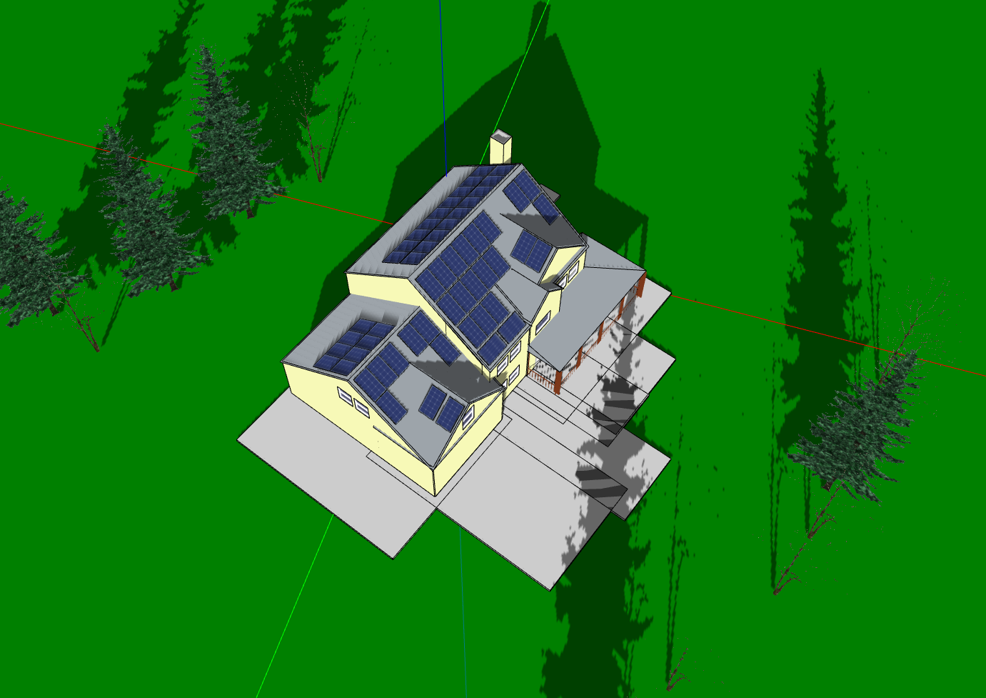 | 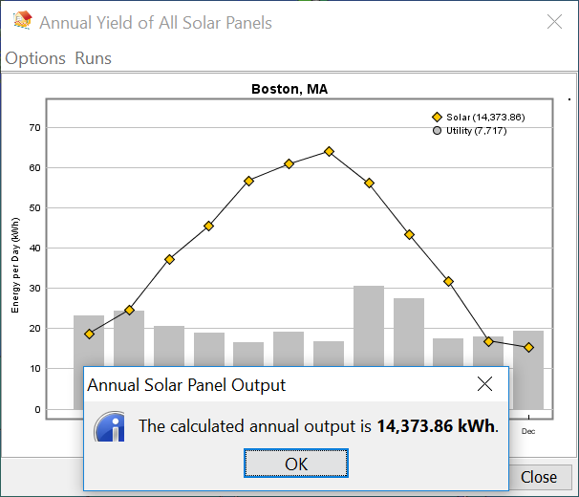
1) Was your design #2 able to produce the amount of energy that meets the need for electricity of the house?

My design #2 shows that the annual output (14374 kWh) exceeds the need for electricity of the house (which is 7717 kWh based on my utility bill). According to the comparison between household usage and system generation on a monthly basis below, solar energy generation of each month almost satisfies the need in every month. Among those months, electricity generation in January, November, and December is slightly less than usage, in February is virtually the same as usage, while in other months the generated electricity significantly exceeds the need.

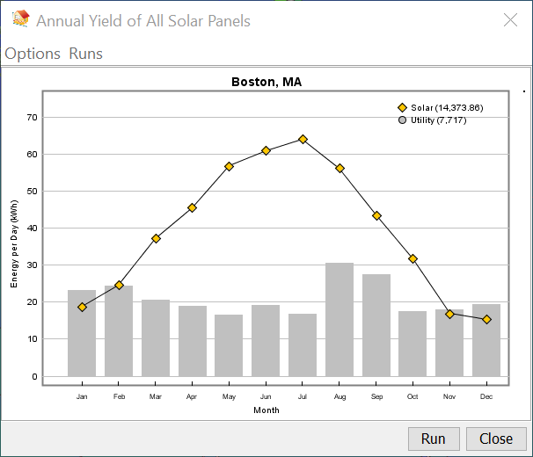
2) What is the brand, wattage, solar cell efficiency, and cost of the panels you selected for Design #1? Why did you select this panel type for your design over other types?

The brand I choose is Sharp NU-U235F3, which has 235 max wattage and 14% efficiency. The total cost of the panels are $39480. I choose this panel type over others since it is the most cost effective, which is explained in detail in design #1.

Design #3, Budget - $60,000
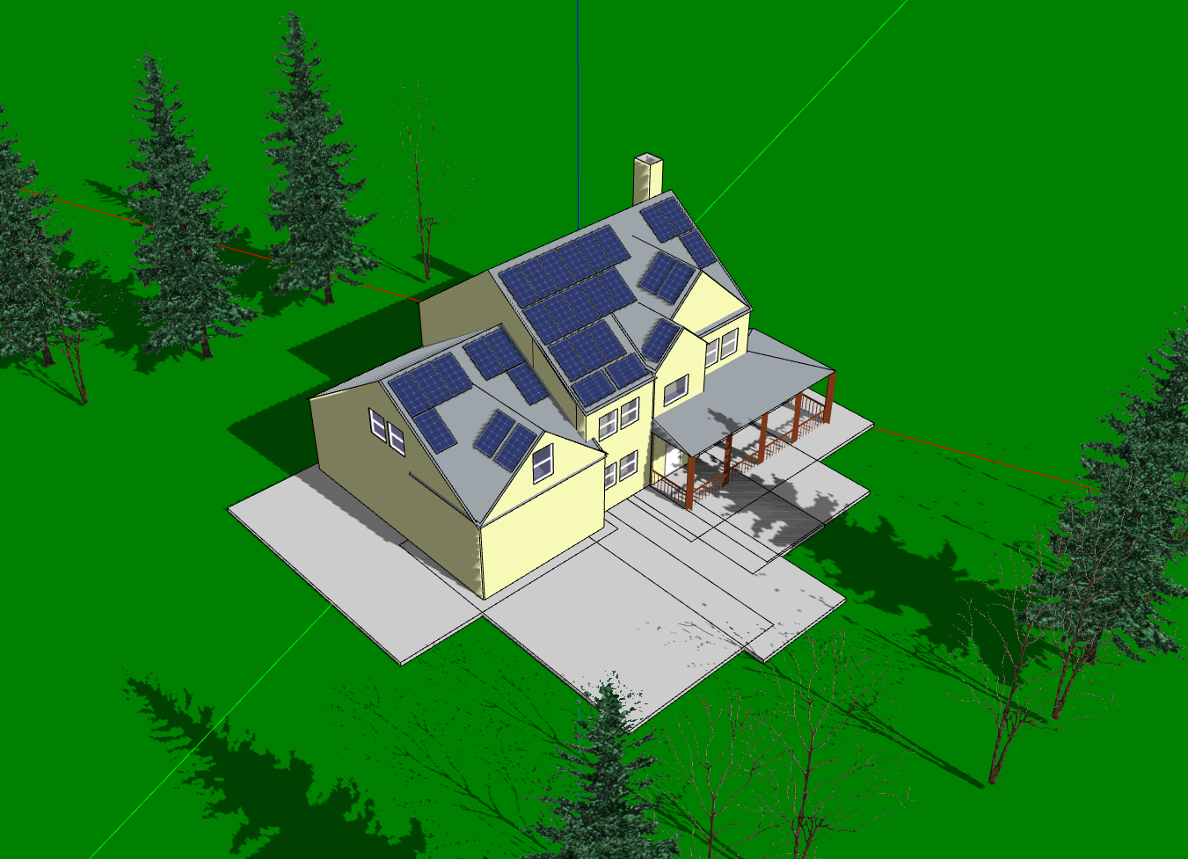 | 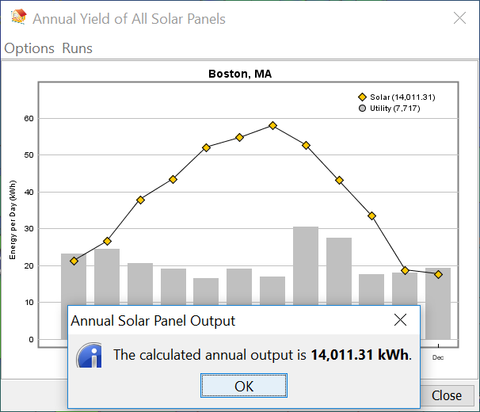
1) Was your design #3 able to produce the amount of energy that meets the need for electricity of the house?

My design #3 shows that the annual output (14011 kWh) exceeds the need for electricity of the house (which is 7717 kWh based on my utility bill). According to the comparison between household usage and system generation on a monthly basis below, solar energy generation of each month adequately satisfies the need. Among those months, electricity generation in January and December is slightly less than usage, in February and November is slightly more than usage, and in other months the produced electricity significantly exceeds the need.
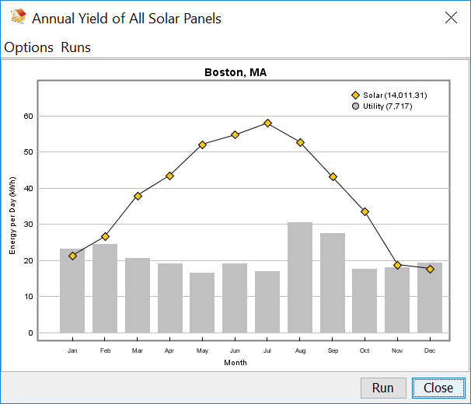
2) What is the brand, wattage, solar cell efficiency, and cost of the panels you selected for Design #3? Why did you select this panel type for your design over other panels?

The brand I choose is SunPower X21-345, which has 345 max wattage and 22% efficiency. The total cost of the panels are $58822.5. I choose this panel type over others since I want solar panels to be as less as possible while meeting the energy needs and given the relatively abundant budget. Theoretically speaking, Sharp NU-U235F3 is the most cost effective choice. However, it takes 85 panels to use up the budget based on my calculation, which is too many for the roof of the house. The same logic applies to Hyundai 280 (61 panels) and LG300N1C (50 panels). SolarCity Triex340 (39 panels) is another choice. However, it cost $59670 as opposed to SunPower X21-345, which costs $58822.5. Based on above considerations, I decided to choose SunPower X21-345.

Part E: Comparative Analysis of the Three Solar Panel Layouts

1) List some of the major advantages and disadvantages of each of your designs (for example, how much energy is produced per cost of the system, environmental impact, and others).
 | Advantages | Disadvantages
Design #1, $20,000 | Costs less to implement.  Relatively less panels, which is more aesthetically acceptable. | No choice but to use the most cost effective panels in order to meet the needs.  Though energy generation could meet the annual household usage, it could not satisfy the needs in winter season.
Design #2, $40,000 | Generates energy that meets both annual and monthly needs.  Could switch to other brands to reach a balance between number of panels and energy output. | Relatively more expensive.  Too many panels on the roof. And certain panels have to be placed to face northwest, which does not maximize the use of them.
Design #3, $60,000 | Uses the newest technology with the most efficiency.  Relatively less panels. | Cost too much money to implement.

2) Now that you have completed three solar panel layout designs, what would you recommend to the family members or friends living in the house you designed layouts for? Use the advantages and disadvantages you listed above to explain and justify your recommendation.

I would recommend to the family members or friends living in the house to choose the design #2. I eliminated design #1 since it does not meet monthly usage in winters when much energy is actually needed. And I cross out design #3 since it cost too much. And the least annual energy production (by choosing SunPower X21-345 based on my calculation) is 14011 kWh, which far exceeds the household usage. I choose design #2 since it seems to be the most cost efficient solution. That is, it costs reasonably low to completely meet the need. Plus, I can easily switch solar panel brand around this budget ($40,000) in order to balance my family member’s or friend’s sense of aesthetics (which is related to the number of panels) and energy produce.

